TUSIIME RONALD

M23B38/017

B20847

GIT HUB REPO: https://github.com/ronaldtusiimekigame/KFC-web-app

KFC WEB APP

This Web App was created to deliver a better service experience for KFC customers in mukono.

It provides a variety of features like

**A home page**

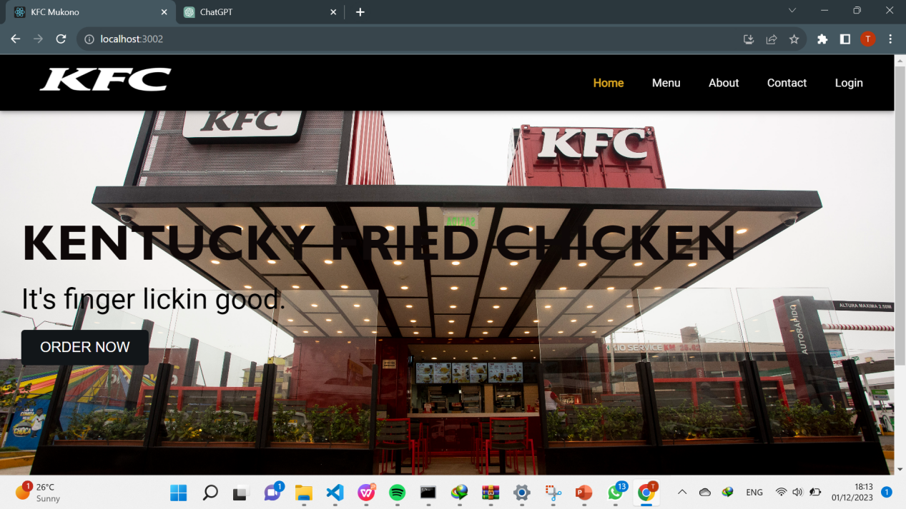

**Menu Page**

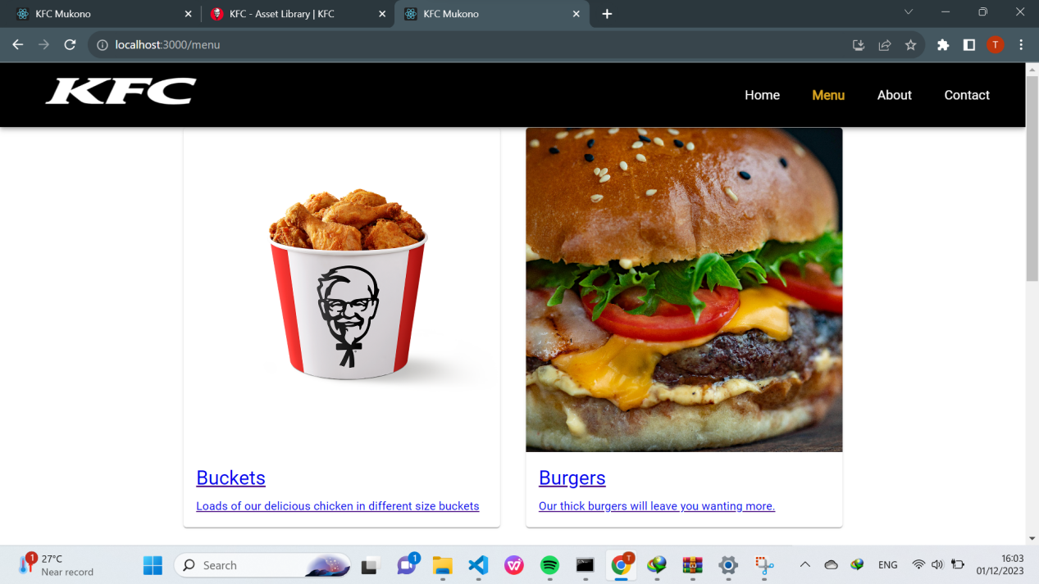

**About us**

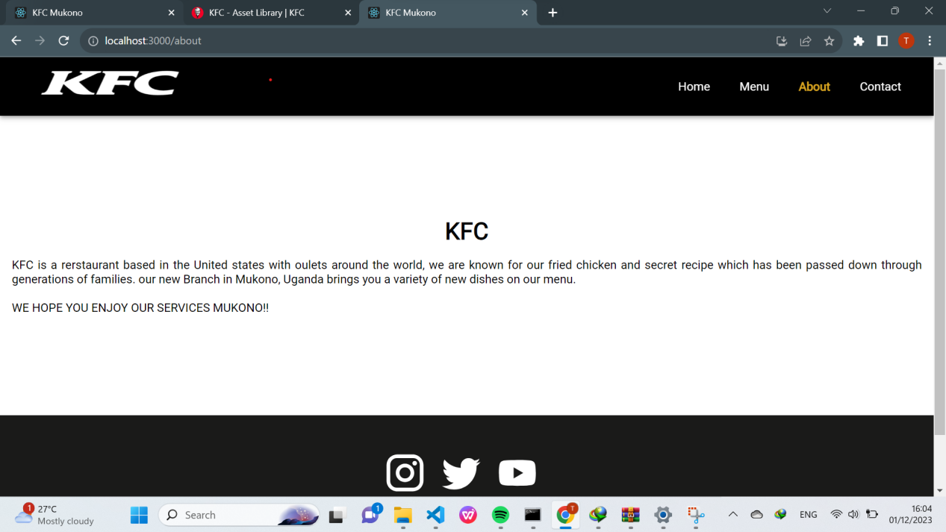

**Contact Page**

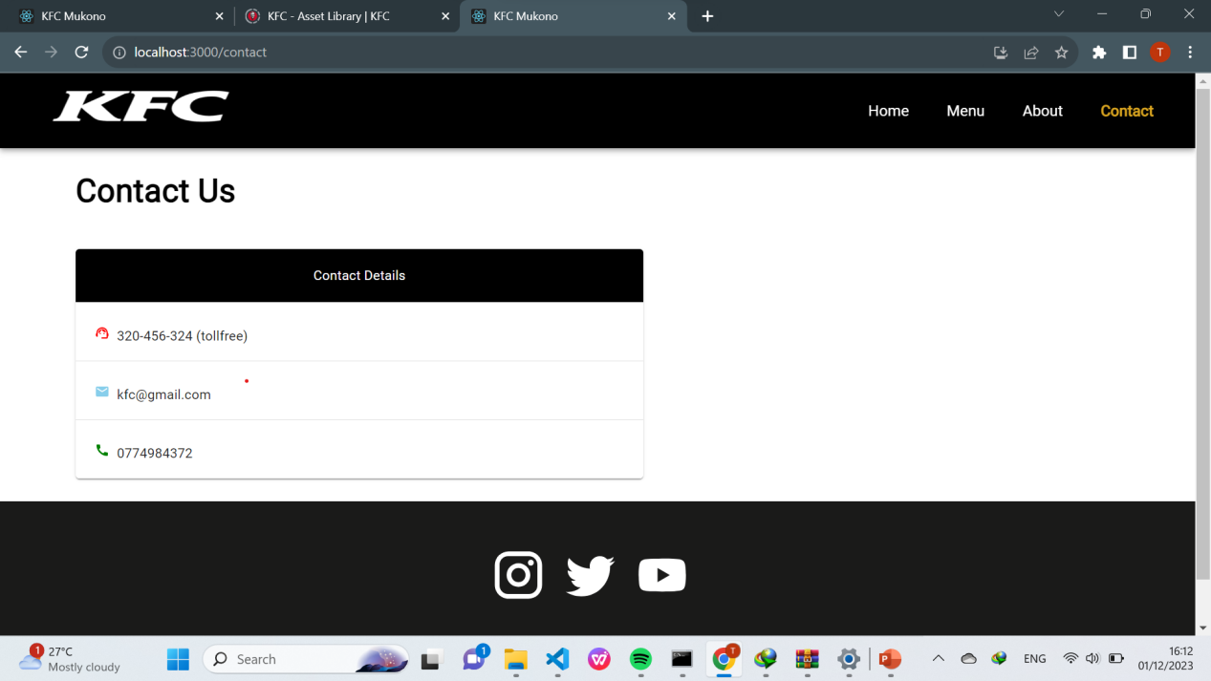

**Cart**

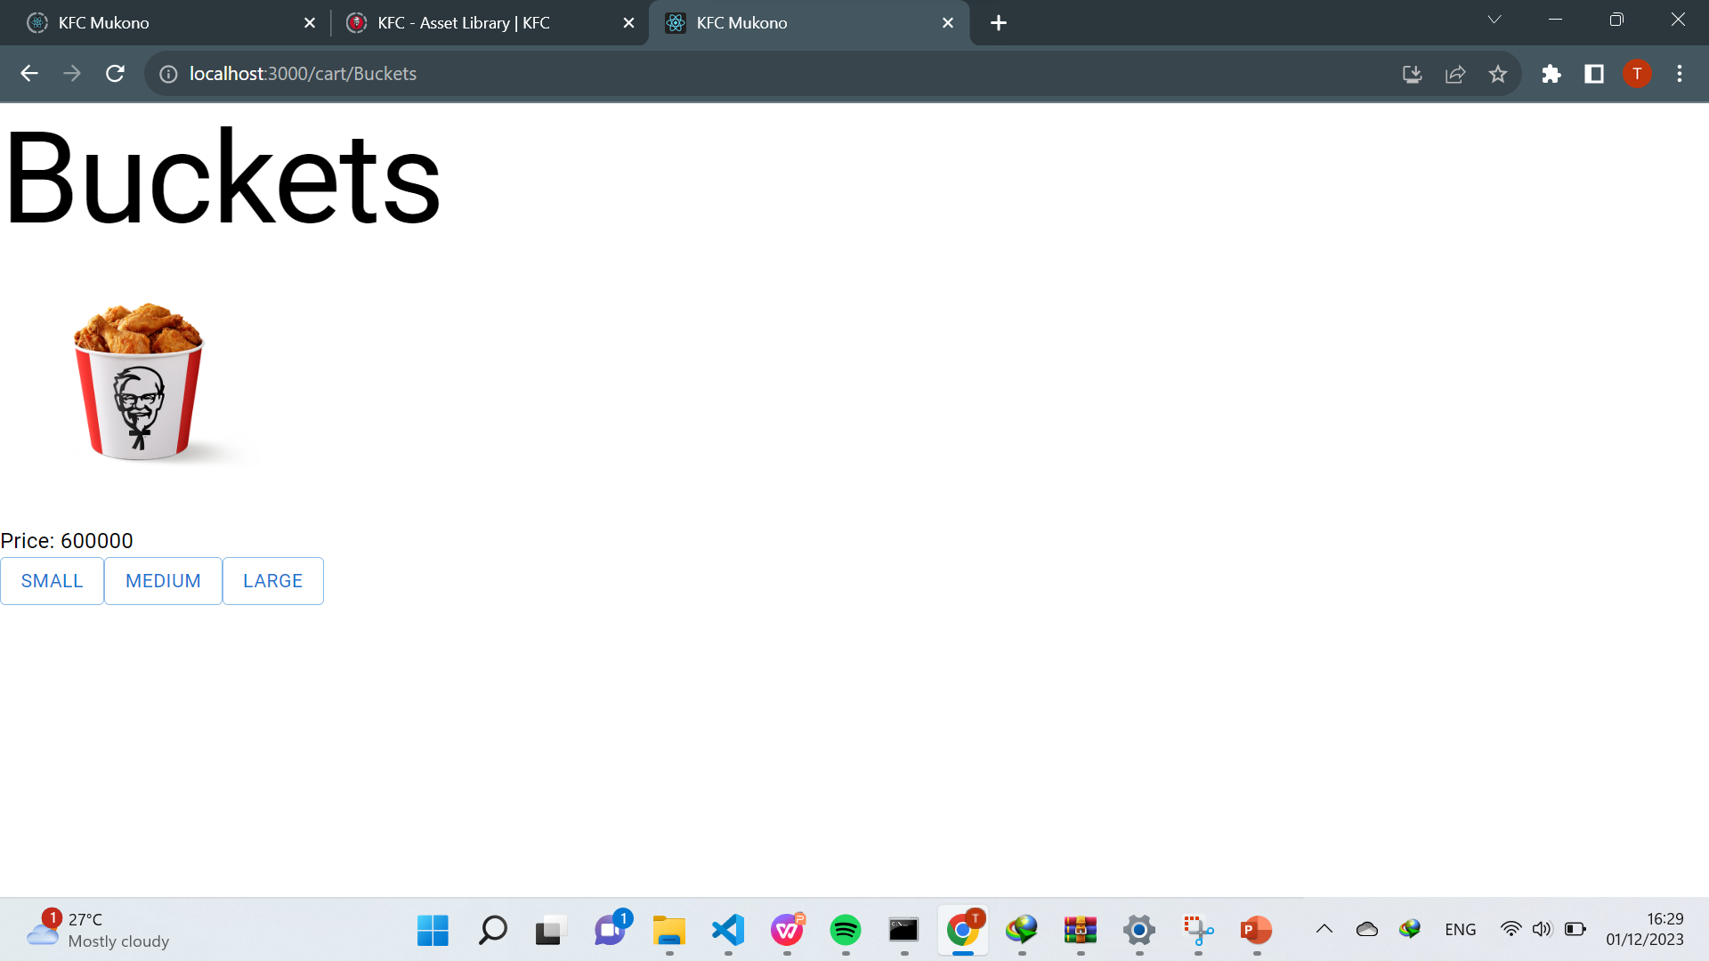

The tools that were used in the build of this application like;

React js

Material UI